Logistic Regression for Classifying Asteroid Impact Risk Using Orbital Features

[The title should clearly and succinctly reflect the main content of the research and be appealing to academic readers. It must consist of 8–12 words (excluding the definite article the and the indefinite articles a, an). Use concise noun or verb phrases rather than full sentences.]

First Author¹, Second Author², ...
Email: email1@mail.smds.ac.id, email2@mail.smds.ac.id,

[In the submission process (Step 3. Entering the Submission's Metadata), Author(s) must fill out authors’ information that consist of author First, Middle and Last Name (if author only uses one name, fill the first name and last name with the same name), Gender, Initial, Username, Password, Affiliation (University / or Institution), E-mail, Mailing Address (complete address of affiliation), Country and Bio Statement.]

Abstract – This study develops a transparent classification model to identify asteroids with a high risk of impacting Earth based on their physical characteristics and orbital parameters. The analysis uses the open dataset Possible Asteroid Impacts with Earth, which provides information on potential impact scenarios, diameter, velocity, impact energy, and key orbital parameters, including the minimum orbit intersection distance with Earth. After merging and cleaning the data, feature engineering was performed to construct variables that capture the intensity of impact scenarios, the scale of impact energy, and the proximity of the orbital path. Class imbalance between high-risk and low-risk asteroids was addressed through class weighting and stratified data splitting, while all numerical predictors were normalised to a comparable scale. The main modelling approach is regularised logistic regression, with hyperparameters selected via grid search and cross-validation. Evaluation on the test set shows that the model achieves an accuracy of 0.8676, a balanced accuracy of 0.8787, and an AUC of 0.947, indicating very strong discriminative ability between high-risk and low-risk asteroids. Coefficient analysis reveals that the number of recorded impact scenarios, asteroid diameter, velocity, and the interaction between velocity and minimum orbit intersection distance are the primary determinants of increased risk. These findings suggest that logistic regression can serve as an effective and interpretable baseline method for the initial screening of potentially hazardous asteroids, although further refinement of decision thresholds and incorporation of dynamic orbital information are still needed to reduce missed detections of high-risk objects.

Keywords: Asteroid impact prediction; Near-Earth objects; Logistic regression; Risk classification; Machine learning

Introduction
In recent decades, Near-Earth Objects (NEOs) have been increasingly recognized as a critical natural hazard (Perna & Barucci 2013). Historical evidence, ranging from large-scale ancient impacts to atmospheric airbursts such as the 2013 Chelyabinsk event, demonstrates that these occurrences, while statistically rare can yield catastrophic consequences for the global environment and human infrastructure (Brown et al. 2013). As next-generation sky surveys and NEO cataloging efforts expand, the volume of detected asteroids is growing exponentially. This data deluge necessitates the development of quantitative approaches capable of processing vast information streams to efficiently prioritize objects for intensive monitoring.
Traditionally, impact risk assessment has relied on physics-based orbital dynamics modeling and computationally intensive numerical simulations, such as those employed by NASA's Sentry system. While these deterministic methods are indispensable for precise trajectory calculation, they are not inherently designed to provide a concise statistical summary of risk factors. Conversely, while the application of machine learning in astronomy has surged, ranging from deep learning for galaxy classification to neural networks for hazard identification many of these predictive models operate as "black boxes," offering high predictive performance at the cost of interpretability (Bacu et al. 2023), (Malakouti 2023). In the context of planetary defense and risk mitigation, transparency is paramount; models must provide not only accurate predictions but also justifiable rationales to support decision-making processes.
To address this gap, this study leverages the "Possible Asteroid Impacts with Earth" dataset to construct an interpretable, logistic regression-based framework for impact risk classification. Logistic regression has been proven effective in various astronomical classification tasks, offering a balance between accuracy and explainability . The analysis integrates physical characteristics, such as diameter, velocity, and impact energy with critical orbital parameters, including the Minimum Orbit Intersection Distance (MOID). Through rigorous preprocessing and feature engineering, these variables are synthesized into predictors representing asteroid dimensions, orbital mechanics, and potential impact intensity. Logistic regression is selected specifically for its explanatory power, yielding explicit probability estimates and coefficients that quantify the relative contribution of each factor to risk escalation.
This study aims to answer two primary research questions. First, to what extent can a logistic regression model, optimized with class-imbalance handling and feature scaling, effectively discriminate between high-risk and low-risk asteroids? Second, which physical and orbital determinants exhibit the strongest correlation with elevated impact probabilities? Accordingly, this article details the data processing pipeline and modeling methodology, evaluates model performance on a held-out test set, and interprets key coefficients to offer actionable insights for the monitoring of potentially hazardous asteroids.

Research Methods
- LOAD DATA
The data used in this study are derived from the secondary dataset Possible Asteroid Impacts with Earth, which consists of two main components: impact scenario data and orbital parameter data. Both components were examined initially and then merged after the asteroid object names were standardized (for example, by removing extra spaces and parentheses) so that each asteroid had a consistent identifier.

After the merge, missing values and duplicate records were checked for key variables, including cumulative impact probability, number of possible impact scenarios, physical characteristics (velocity, magnitude, diameter, impact energy), and orbital parameters (eccentricity, inclination, semi-major axis, and minimum orbit intersection distance with Earth). Observations lacking complete information on these variables were removed, ensuring that subsequent analyses were based only on complete and internally consistent records and thereby minimizing distortion in the modeling results.

- OVERVIEW DATASET
After the two data files were merged, the next step was to examine the structure and content of the resulting dataset that forms the basis of the modelling. Each row represents a single asteroid that may approach or potentially impact the Earth, with information covering both its physical characteristics and orbital parameters, thereby providing a reasonably comprehensive description of the dynamical state of each object.

The main variables used in this study include the cumulative impact probability (Cumulative Impact Probability), the recorded number of impact scenarios (Possible Impacts), relative velocity (Asteroid Velocity), apparent magnitude (Asteroid Magnitude), diameter in kilometres (Asteroid Diameter (km)), and impact energy in megatons (Impact Energy (Mt)). In addition, several key orbital parameters are considered, such as eccentricity (Orbit Eccentricity), inclination (Orbit Inclination (deg)), semi-major axis (Orbit Axis (AU)), and the minimum orbit intersection distance with Earth (Minimum Orbit Intersection Distance (AU)). The combination of these variables enables impact risk modelling that jointly accounts for both the physical properties and orbital dynamics of the asteroids.

To preserve data quality, the presence of missing values and duplicate entries was re-examined for these key variables. Only observations with complete information were retained in the final dataset, and asteroid identifiers were checked to prevent duplicated objects that could bias the analysis. In this way, the dataset used is expected to consistently reflect the physical and orbital conditions of the asteroids, leading to more reliable impact risk modelling results.

- PREPROCESSING DATA
Before model estimation, the combined data were subjected to several preprocessing steps to ensure adequate quality. The first step was to identify the presence of missing values in each variable and to quantify them at the column level. Observations that lacked complete information on key variables were removed from the dataset to reduce bias and uncertainty arising from incomplete records, so that subsequent analyses relied only on fully observed rows.

Next, the asteroid identifiers were examined to ensure that each object was recorded only once. When more than one row with the same object name was detected, the corresponding records were reviewed and harmonised so that a single asteroid was represented by a single, consistent entry. This step is important to prevent any individual object from exerting a disproportionate influence on the modelling results.

Once the data were free from missing values and duplicates, the variables most relevant to the research objective were selected, namely those describing impact potential (cumulative impact probability and number of possible impacts), physical characteristics of the asteroid (velocity, magnitude, diameter, impact energy), and core orbital parameters (eccentricity, inclination, semi-major axis, and minimum orbit intersection distance with Earth). This selection helps to simplify the data structure without discarding essential information, resulting in a clean and well-organised dataset ready for statistical modelling.

- FEATURE ENGINEERING
After the data had been cleaned and the main variables selected, a feature engineering stage was carried out (see Table 1) to enrich the information supplied to the model and to capture patterns that are not directly visible in the original variables. The first step was to remove variables that could cause data leakage, namely columns that already summarize impact risk, such as cumulative and maximum Palermo scale, maximum Torino scale, and cumulative impact probability. Including these variables would allow the model to effectively “cheat,” leading to overly optimistic performance estimates that do not reflect its true predictive capability.

Subsequently, several physical variables were transformed and combined as summarised in Table 1. Logarithmic transformations were applied to the number of possible impacts, diameter, velocity, and impact energy in order to dampen the influence of extreme values and stabilise their distributions. In addition, interaction terms were constructed that combine diameter, velocity, number of possible impacts, and the minimum orbit intersection distance (MOID), reflecting the notion that impact risk is driven by joint effects of size, speed, and the frequency of impact scenarios rather than by any single factor alone. Several variables were also squared (for example, velocity, diameter, and eccentricity) to highlight differences between moderate and genuinely extreme conditions. All derived features were then re-screened, and only those that are physically meaningful and statistically stable were retained as final inputs to the classification model.

Table 1. Summary of Feature Engineering

Feature | Formula
log_impacts | log(Possible Impacts)
log_diameter | log(Asteroid Diameter (km))
log_velocity | log(Asteroid Velocity)
log_energy | log(Impact Energy (Mt))
diameter_x_velocity | $$Diameter × Velocity$$
velocity_x_MOID | $$Velocity × MOID$$
diameter_x_impacts | $$Diameter× Possible Impacts$$
velocity_x_impacts | $$Velocity× Possible Impacts$$
velocity2 | $${Velocity}^{2}$$
diameter2 | $${Diameter}^{2}$$
ecc2 | $${Orbit Eccentricity}^{2}$$
inclination2 | $${Orbit Inclination}^{2}$$
axis2 | $${Orbit Axis}^{2}$$
MOID2 | $${MOID}^{2}$$
perihelion | $$q=a(1-e)$$
peri_aphe_ratio | $$Q=a(1+e)$$
q_norm_axis | $$q/a$$
Q_norm_axis | $$Q/a$$
sin_inclination | $$sin(Inclination ×π/{180}$$
cos_inclination | $$cos(Inclination ×π/{180}$$

- PEMILIHAN FITUR UNTUK MODEL
Once the original and derived variables had been constructed in the feature engineering stage, the next step was to select the subset of features actually used as inputs to the model. This selection was guided by two main considerations: substantive relevance to impact risk and statistical suitability. Substantively, only variables that are logically related to the magnitude of risk were retained, such as asteroid size and velocity, the frequency of recorded impact scenarios, and the proximity of the orbital path to Earth. Statistically, care was taken to avoid features that are redundant in terms of information content, that directly encode risk scores or indexes, or that suffer from substantial missingness after data cleaning.

In broad terms, the candidate features were grouped into several categories. The first category comprises logarithmically transformed variables (log diameter, log velocity, log number of possible impacts, and log impact energy), which help stabilise skewed distributions and make differences between asteroids more proportional. The second category includes core orbital parameters that describe the orbital geometry, namely semi-major axis, eccentricity, inclination, minimum orbit intersection distance with Earth, perihelion and aphelion distances, and orbital period. The third category consists of interaction terms that combine physical characteristics and orbital proximity, such as diameter × velocity, diameter × number of possible impacts, velocity × number of possible impacts, and combinations of physical quantities with the minimum orbit intersection distance. In addition, a set of polynomial terms (squared eccentricity, inclination, semi-major axis, velocity, diameter, and minimum orbit intersection distance) was used to highlight differences between moderate and extreme orbital conditions.

Finally, several derived variables capturing orbital dynamics in a more refined way were retained, including the perihelion–aphelion ratio, sine and cosine components of the inclination angle, and perihelion and aphelion distances normalised by the semi-major axis. All candidate features were then consolidated into a single list of explanatory variables, and only those that were consistently available in the cleaned dataset and physically interpretable were ultimately included in the model. In this way, the logistic regression classifier was built on a feature set that is information-rich, physically meaningful, free from direct risk-score leakage, and statistically stable for impact risk classification.

- TRAIN-TEST SPLIT
Once the feature set and target variable had been defined, the data were split into two subsets: a training set and a test set. Approximately 80% of the observations were allocated to the training set for model fitting and tuning, while the remaining observations were reserved as a held-out test set, used only at the final stage as an independent benchmark of model performance. This separation is essential to assess the model’s ability to generalise to previously unseen data and to avoid overly optimistic performance estimates.

The split was performed in a stratified manner, preserving the proportion of high-risk and low-risk asteroids in both the training and test sets so that it remained comparable to the original class distribution. A fixed random seed was used to ensure that the train–test split is fully reproducible. After the split, the class distribution in each subset was re-examined to confirm that the training data remained representative and that evaluation on the test set genuinely reflects the model’s ability to distinguish between the two risk categories.

- SCALING
After the data had been split into training and test sets, all numerical predictor variables were rescaled to a common scale. The aim of this step was to ensure that each variable lies within a comparable range, so that no single variable dominates the modelling process merely due to differences in units or order of magnitude. Without such rescaling, variables with very large values, such as orbital distance in astronomical units, could overshadow the influence of other important variables such as asteroid diameter or velocity.

In this study, a standardisation approach was used, whereby each numerical predictor in the training set was transformed to have zero mean and unit standard deviation. The resulting means and standard deviations were computed exclusively from the training data and then applied to standardise the test data, thereby preventing any information leakage from the test set into the training process. This rescaling is particularly important because the chosen model regularised logistic regression is sensitive to differences in the scale of explanatory variables. Through this scaling step, a more balanced set of predictors is obtained, providing a suitable basis for modelling the classification of asteroid impact risk.

- IMBALANCE HANDLING
In the next stage, attention was directed to the issue of class imbalance in the target variable. By construction, the number of asteroids classified as high-risk is much smaller than the number classified as low-risk. If this imbalance is ignored, the model tends to “play safe” by almost always predicting the low-risk class: the overall accuracy may appear high, but the ability to correctly identify high-risk asteroids becomes poor. This situation is not aligned with the aim of the study, since in practical terms it is more important to minimise failures in detecting objects that may pose a threat to Earth.

To mitigate this problem, the model was made more sensitive to errors in the high-risk class by assigning a higher penalty to misclassifications of high-risk asteroids than to those of low-risk asteroids. In this way, the learning algorithm is effectively reminded that labelling a dangerous asteroid as non-dangerous is far more serious than the opposite error. This weighting strategy complements the stratified train–test split applied earlier, so that the imbalanced class distribution remains realistic while its impact on training and evaluation can be controlled.

In addition, oversampling techniques on the training data were considered on an exploratory basis to increase the representation of the minority class, allowing the model to see more examples of high-risk asteroids during learning. Any modification of the class distribution was evaluated carefully to avoid introducing overly artificial patterns. Through this combination of adjustments, the model is expected not only to achieve good overall performance but also to exhibit a more balanced ability to discriminate between high-risk and low-risk asteroids.

- TRAINING LOGISTIC REGRESSION DAN HPO (GRIDSEARCH)
At this stage, the study employs logistic regression as the primary model to classify asteroids into high-risk and low-risk groups. The choice of logistic regression is motivated by two main considerations. First, the model naturally produces a probability that a given asteroid belongs to the high-risk class, which makes the output easy to interpret in a decision-making context. Second, the regression coefficients provide direct information on the direction and magnitude of the effect of each explanatory variable on the increase or decrease of impact risk.

Model training was carried out using only the training data that had undergone scaling and class-imbalance handling. To reduce the risk of overfitting and improve generalisation, a regularised form of logistic regression was adopted, in which a penalty term is added to shrink excessively large coefficients. The strength of this penalty is governed by hyperparameters that were not chosen arbitrarily, but tuned through a hyperparameter optimisation procedure based on grid search.

In the grid search, a set of plausible hyperparameter combinations was first specified, and each combination was then evaluated using cross-validation on the training data. The training set was partitioned into several folds; for each combination, the model was fitted on a subset of folds and evaluated on the remaining fold, and this process was repeated so that each fold served as validation data in turn. Performance metrics—primarily accuracy and the area under the ROC curve (AUC)—were averaged across folds, and the hyperparameter combination with the best average performance was selected as the final configuration. The logistic regression model was then refitted on the full training set using this configuration, yielding a final model ready to be evaluated on the test data and to be used for assessing classification performance and the contribution of each feature to asteroid impact risk.

Results and Discussion
- OVERALL MODEL PERFORMANCE
Table 1. Classification Report

Metric | Value
Accuracy | 0.8676
95% CI for accuracy | 0.7989 – 0.9196
No Information Rate | 0.6618
p-value (Accuracy > NIR) | 4.01 × 10⁻⁸
Kappa | 0.7193
McNemar’s test p-value | 0.0339
Sensitivity | 0.8444
Specificity | 0.9130
Positive predictive value (PPV) | 0.9500
Negative predictive value (NPV) | 0.7500
Prevalence of positive class | 0.6618
Detection rate | 0.5588
Detection prevalence | 0.5882
Balanced accuracy | 0.8787
Area under ROC curve (AUC) | 0.9473

Tabel 1 merangkum kinerja keseluruhan model regresi logistik pada data uji. Model menghasilkan akurasi 0,8676, jauh di atas No Information Rate sebesar 0,6618 dengan nilai p 4,01 × 10⁻⁸, sehingga peningkatan ini signifikan secara statistik. Interval kepercayaan 95% untuk akurasi (0,7989–0,9196) relatif sempit dan tetap berada di atas No Information Rate, yang mengindikasikan estimasi yang stabil. Selain itu, nilai Kappa 0,7193 dan balanced accuracy 0,8787 menunjukkan kesesuaian yang kuat antara prediksi model dan kelas aktual, tidak hanya mengikuti dominasi kelas mayoritas. Secara umum, hasil ini menegaskan bahwa model yang dibangun memberikan performa klasifikasi yang andal sebagai dasar untuk analisis lebih lanjut.
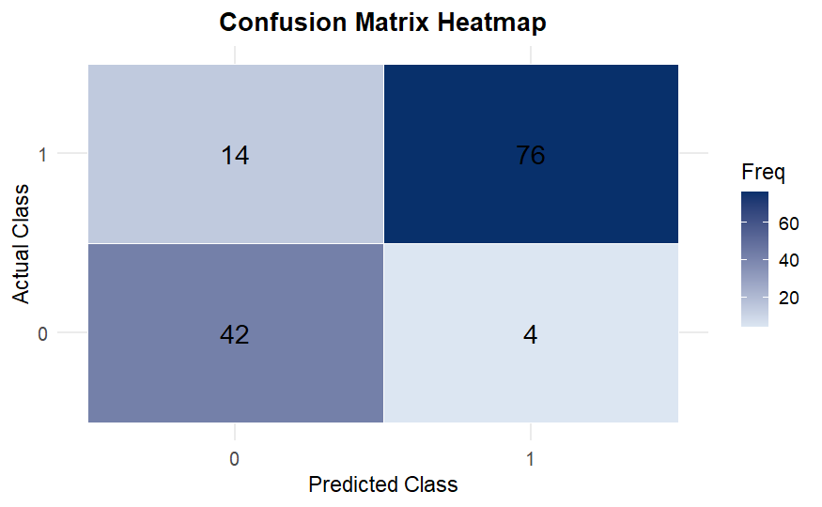
- CLASS-WISE PERFORMANCE & CONFUSION MATRIX

Figure 1. Confusion Matrix Heatmap

Kinerja model pada masing-masing kelas ditunjukkan oleh confusion matrix pada Gambar 1. Model berhasil mengklasifikasikan 76 asteroid berisiko tinggi secara benar (true positive) dan 42 asteroid berisiko rendah secara benar (true negative), sementara masih terdapat 14 asteroid berisiko tinggi yang diprediksi sebagai berisiko rendah (false negative) dan 4 asteroid berisiko rendah yang diprediksi berisiko tinggi (false positive). Pola ini konsisten dengan nilai sensitivitas 0,8444 dan spesifisitas 0,9130, di mana model cukup baik dalam mengenali kedua kelas, namun masih meloloskan sebagian kecil objek berisiko tinggi. Secara praktis, keberadaan false negative ini menunjukkan bahwa pemilihan ambang probabilitas perlu mempertimbangkan trade-off antara peningkatan sensitivitas dan jumlah peringatan yang dihasilkan.
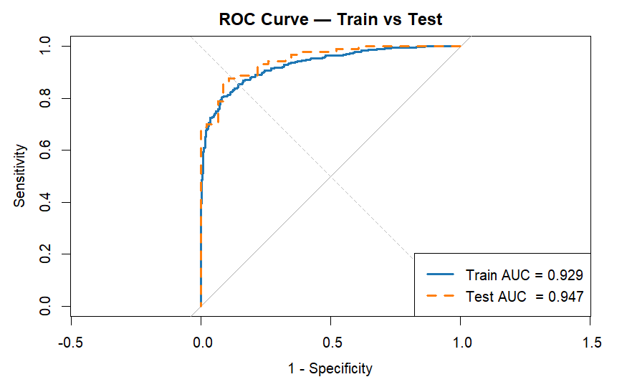
- ROC CURVE AND DISCRIMINATIVE ABILITY

Figure 2. ROC Curve – Train vs Test

Kemampuan diskriminatif model diilustrasikan pada kurva ROC pada Gambar 1. Baik untuk data latih maupun data uji, kurva berada jauh di atas garis diagonal, yang menunjukkan bahwa model mampu membedakan asteroid berisiko tinggi dan rendah pada berbagai ambang probabilitas. Nilai AUC sebesar 0,929 pada data latih dan 0,947 pada data uji mengindikasikan kualitas klasifikasi yang sangat baik sekaligus tidak menunjukkan indikasi overfitting, karena performa pada data uji justru sedikit lebih tinggi. Dengan kata lain, model secara konsisten memberikan probabilitas lebih besar kepada asteroid yang benar-benar berisiko tinggi, sehingga layak dipertimbangkan sebagai alat bantu screening awal.

- IMPLICATION, COMPARISON, AND LIMITATION
Table 2. Top 5 Koefisien Fitur Logistic Regression

Feature | Coef
log_impacts | 2.24677834
log_diameter | 1.08292464
diameter_x_velocity | 0.84225898
velocity2 | 0.75958655
velocity_x_MOID | 0.56657751

Tabel 2 menampilkan lima koefisien positif terbesar dari model regresi logistik. Variabel log_impacts memiliki koefisien paling besar, diikuti oleh log_diameter, yang menunjukkan bahwa banyaknya skenario tumbukan yang tercatat dan ukuran asteroid merupakan penentu utama peningkatan risiko. Interaksi antara diameter dan kecepatan, kuadrat kecepatan (velocity²), serta kombinasi kecepatan dengan jarak minimum perpotongan orbit (velocity × MOID) juga berkontribusi positif, sehingga asteroid yang lebih besar, lebih cepat, dan melintas lebih dekat dengan orbit Bumi cenderung diklasifikasikan sebagai berisiko tinggi. Pola ini sejalan dengan penalaran fisik bahwa energi tumbukan dan kedekatan lintasan menjadi faktor kunci potensi bahaya.

Temuan tersebut mengindikasikan bahwa regresi logistik tidak hanya memberikan kinerja klasifikasi yang baik, tetapi juga mampu mengidentifikasi faktor-faktor risiko yang mudah diinterpretasikan oleh peneliti dan pengambil kebijakan. Meski demikian, masih ditemukannya false negative dan keterbatasan pada penggunaan parameter orbit yang bersifat statis menunjukkan bahwa model ini sebaiknya dipandang sebagai alat screening awal yang perlu dilengkapi dengan pemodelan dinamika orbit yang lebih rinci atau model lain yang lebih konservatif dalam mendeteksi asteroid berisiko tinggi.

Conclusion
This study developed a logistic regression model to classify asteroids into high-risk and low-risk categories using the Possible Asteroid Impacts with Earth dataset. After a sequence of preprocessing, feature engineering, class-imbalance handling, and scaling steps, the resulting model achieved an accuracy of 0.8676, a balanced accuracy of 0.8787, and an AUC of 0.947 on the test set. These results indicate strong discriminative capability between the two classes and demonstrate that a relatively simple statistical approach can deliver competitive classification performance. Coefficient analysis further shows that the number of recorded impact scenarios, asteroid diameter, velocity, and the interaction between velocity and minimum orbit intersection distance are the main factors driving higher impact risk.

Nevertheless, the presence of false negatives and the reliance on static physical and orbital parameters suggest that the proposed model is not sufficient as a stand-alone early warning system. The logistic regression model is more appropriately positioned as a transparent and interpretable screening tool to support the prioritisation of potentially hazardous asteroids. Future work is recommended to explore the calibration of decision thresholds, incorporate dynamic orbital information, and compare this approach with more complex machine learning models in order to further improve sensitivity to high-risk objects.

Acknowledgement
The authors must acknowledge any sources of funding that supported the research and may acknowledge the outside reviewers of their drafts. Please provide after passing the review process.

References
The references must consist of 80% from relevant and recent primary sources (such as article of journal or conference from last 5 years). Citations and References are adapted from IEEE style and using reference manager software (Mendeley, Zotero, etc). Guidelines to IEEE style used for in-text citations and references is available http://www.ieee.org/documents/ieeecitationref.pdf However, some adjustments are made to suit the need of CommIT. A quick guide as example is stated as follows. The samples below are taken randomly from various sources and for example purposes only. They are intended neither as ads and promos nor as the Editorial Board’s viewpoint or preferences

- D. Broman et al., “The company approach to software engineering project courses,” IEEE Trans. Educ., vol. 55, no. 4, pp. 445–452, Nov. 2012.
- “Computer science curriculum 2008—An interim revision of CS 2001,” Interim Review Task Force, 2008.
- E. Carr et al., “Living in the knowledge society community building proj- ect,” in Proc. 40th ACM Tech. Symp. Comput. Sci. Educ., Chattanooga, TN, USA, 2009, Rev. 47, pp. 777–780.
- W. Chung, E. Fox, S. Sheetz, and S. Yang, “LIKES: Educating the next generation of knowledge society builders,” in Proc. AMCIS, San Francisco, CA, USA, 2009, pp. 1–10.
- Bologna Working Group on Qualifications Frameworks, A Framework for Qualifications of the European Higher Education Area. Last accessed Jun. 2015. [Online]. Available: http://www.bologna- bergen2005.no/Docs/00Main_doc/050218_QF_EHEA.pdf

